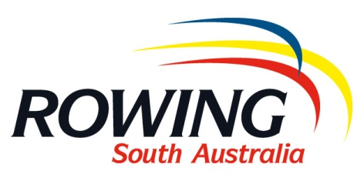

NOMINATION TO HOST A REGATTA DURING THE 2020/21 SEASON

Please return form to Bec Lannan (blannan@rowingsa.asn.au) by close of business Friday 31 July 2020.

Host School/Club: ____________________________________________________________________

Co-Host School/Club: __________________________________________________________________

Nominated Regatta Coordinator: _________________________________________________________

Phone: ___________________________ Mobile: ________________________________

Email: ______________________________________________________________________

1st Preference Regatta: _______________________________________________________________

2nd Preference Regatta: _______________________________________________________________

3rd Preference Regatta: _______________________________________________________________

Comments:

_____________________________________________________________________________________

_____________________________________________________________________________________

_____________________________________________________________________________________

_____________________________________________________________________________________

_____________________________________________________________________________________

_____________________________________________________________________________________

